**START DAY AND END DAY**

The **Branch Collection Reconciliation** page is designed to manage and track the collection details of a branch. Below is a breakdown of the fields and functionalities in a professional format:

**1. Branch Collection Details:**

* **Branch Name**: The name of the branch for which the collection details are being recorded.
* **Opening Cash**: The cash amount collected by the Chief Security Officer (CSO) at the start of the day or collection period.
* **Branch Collection**: A table where the following details are captured:
  + **Serial No.**: A unique identifier for each entry.
  + **User ID**: The identification of the person (typically CSO) who recorded the collection.
  + **Amount**: The cash collected by the CSO.
  + **Action**: An option for the CSO to submit the recorded collection amount.

**2. Branch Collection by FO (Field Officer):**

* **Table Details**: This section displays a table with the following fields for monitoring the collections made by Field Officers (FOs):
  + **Serial No.**: A unique identifier for each entry.
  + **User ID**: The identification of the FO who made the collection.
  + **SM Code**: The Service Manager code linked to the transaction.
  + **Amount**: The amount collected by the FO.
  + **VNO**: Voucher number associated with the collection.
  + **Collection Date (Coll Dt)**: The date when the collection was made.
  + **Creator**: The user who created the entry.
  + **Action**: An option for the branch manager to approve or reject the collection. The branch manager can tick the box to approve the collection.

**3. Branch Collection Approved List:**

* **Approved List**: Displays a list of collections that have been approved by the branch. These collections are considered finalized after the approval from the branch manager.

**4. Branch Query Logs:**

* **Query Details**: A section where any issues or queries raised by the branch are logged. The table includes:
  + **Serial No.**: Unique identifier for the query.
  + **Customer Name (Cust Name)**: The name of the customer related to the query.
  + **SM Code**: The Service Manager code for reference.
  + **Amount**: The amount involved in the query.
  + **Collection Date**: The date when the collection was made or queried.
  + **Action**: Details of any action taken on the query.

H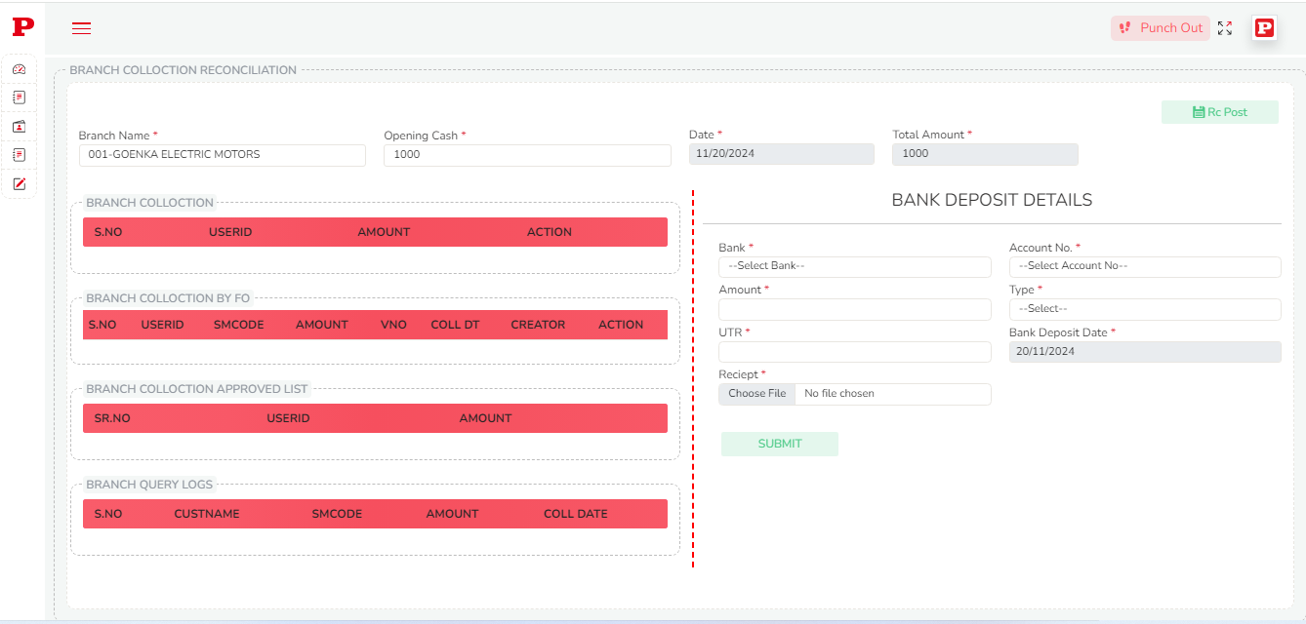

**5. Total Amount:**

* **Total Collection Amount**: A summary of the total amount collected by the CSO across all entries in the branch collection section.

**6. RC Post:**

* **Manual Entry**: The CSO can manually add collection amounts for reconciliation under the RC Post section. This allows for any additional entries not captured earlier.

**7. Bank Deposit Details:**

* **Account Entries**: This section is handled by the accounts department and records the total collection amount deposited into the bank. It includes detailed entries such as deposit dates and amounts.

**Summary:**

The Branch Collection Reconciliation page provides an organized flow of tracking cash collections from the initial collection by CSOs, approval by branch managers, query handling, and final deposit details. Each section ensures transparency and accountability through systematic logging, approval mechanisms, and reconciliation steps.